Vpc 01 task

- Create VPC with 2 private and 2 public subnets.
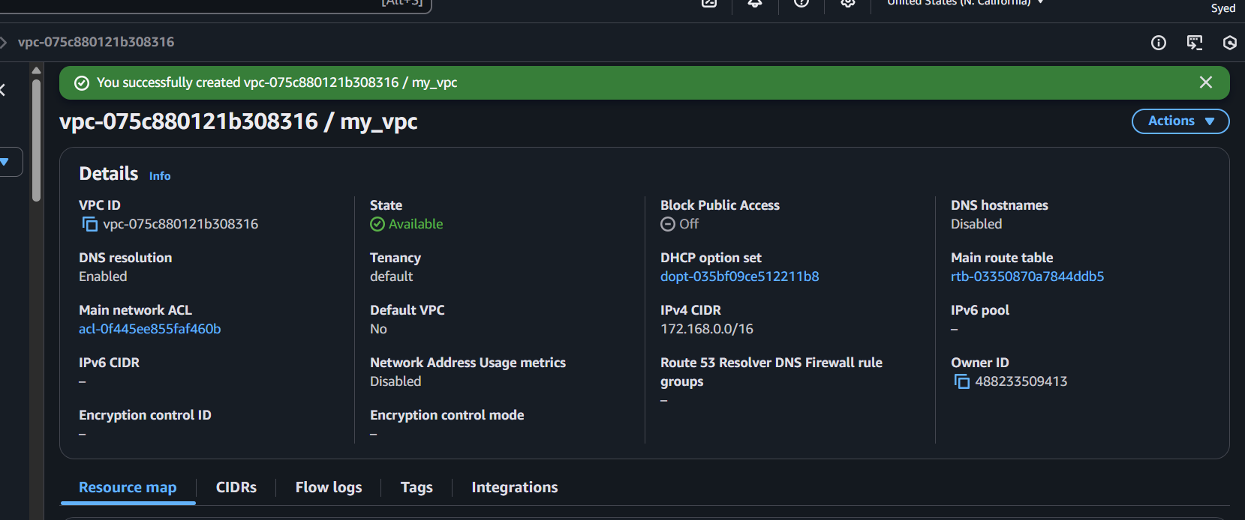
I have created subnet pub 01
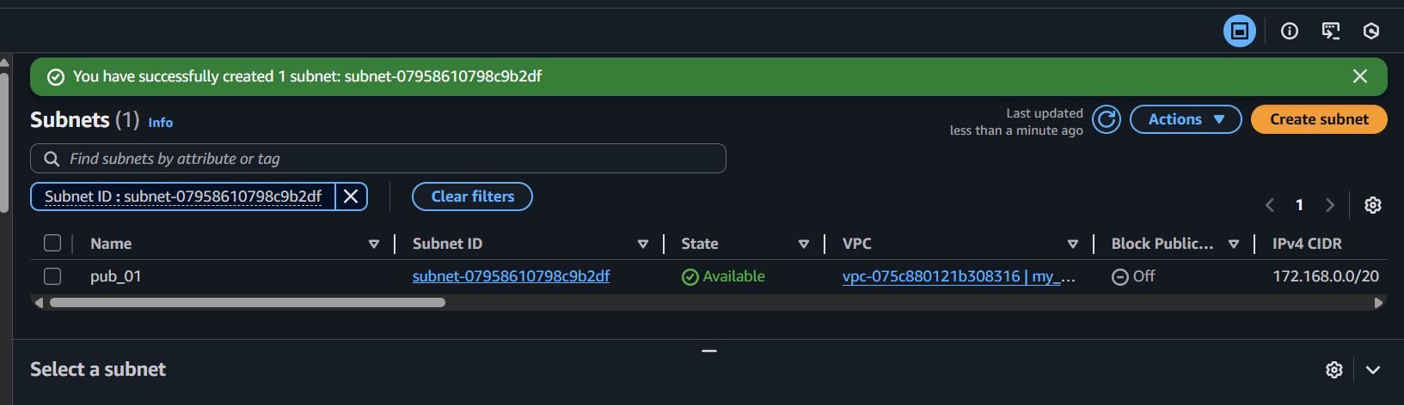

Pub_02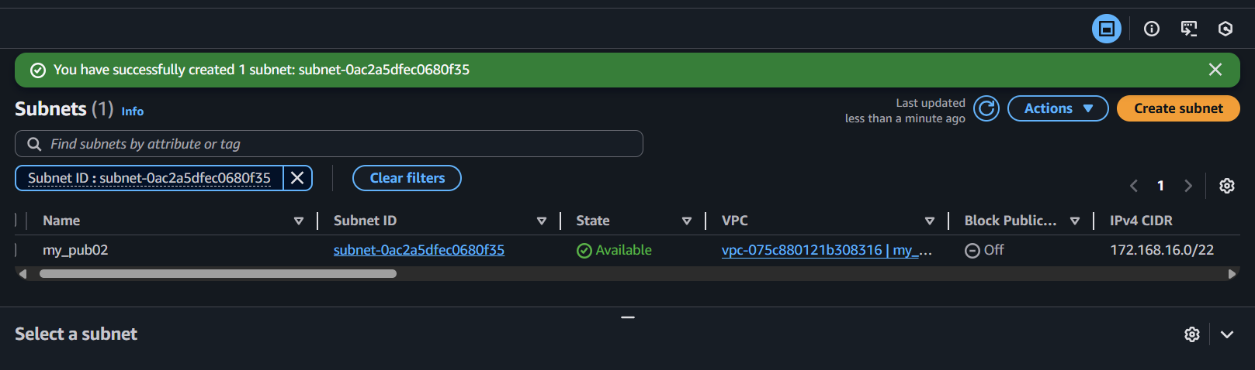Piv 01
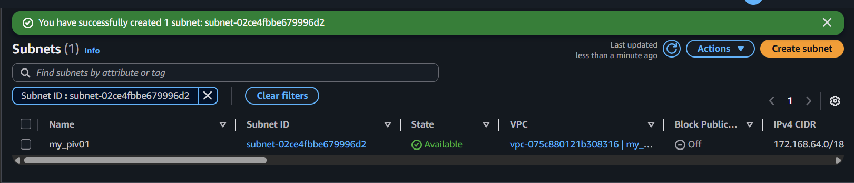

Piv 02
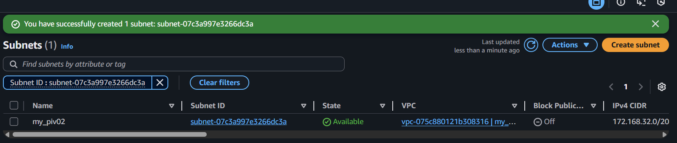

- Enable DNS Hostname in VPC.
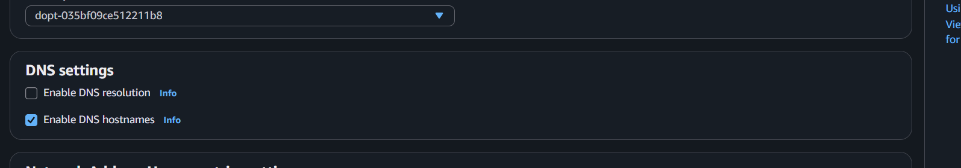
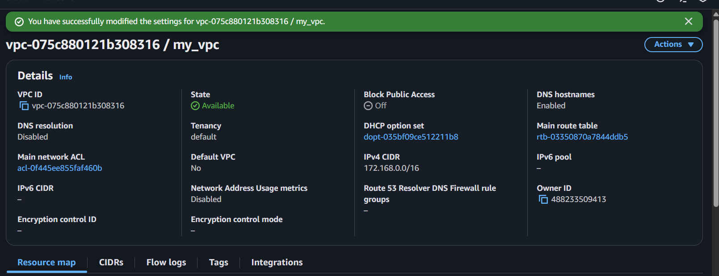

- Enable Auto Assign Public IP in 2 public subnets.
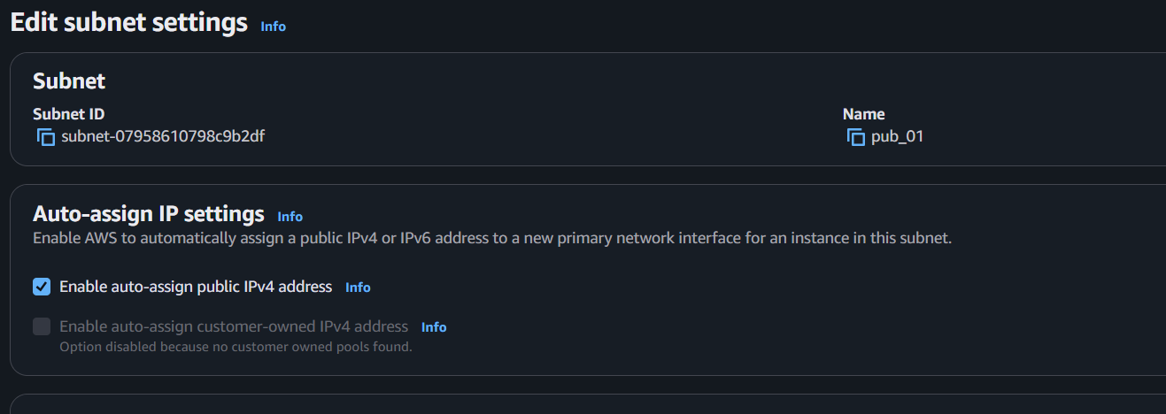
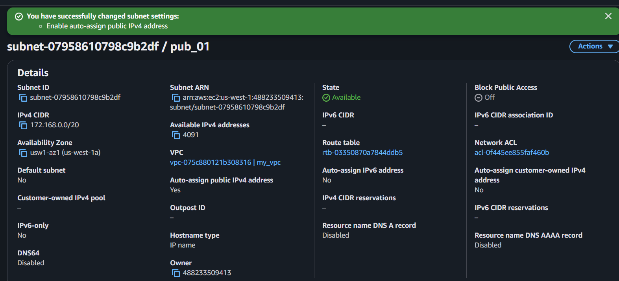

Pub 02
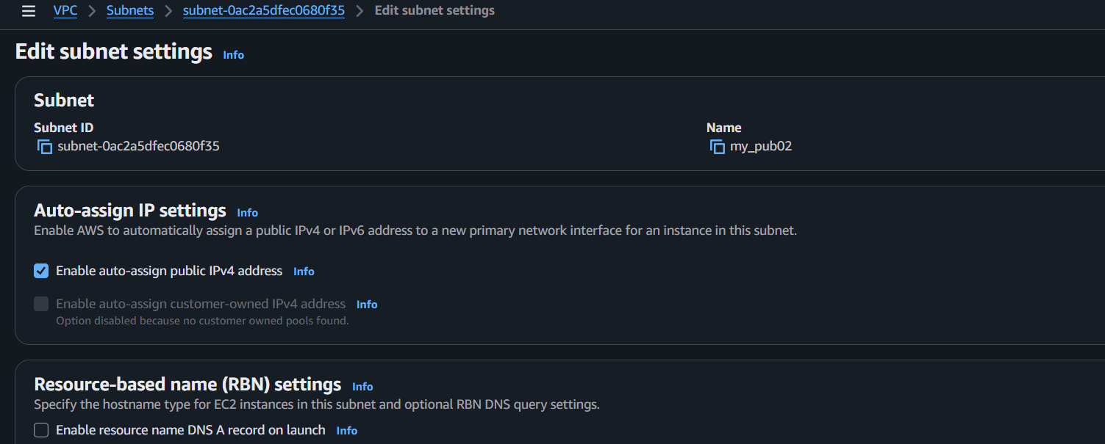

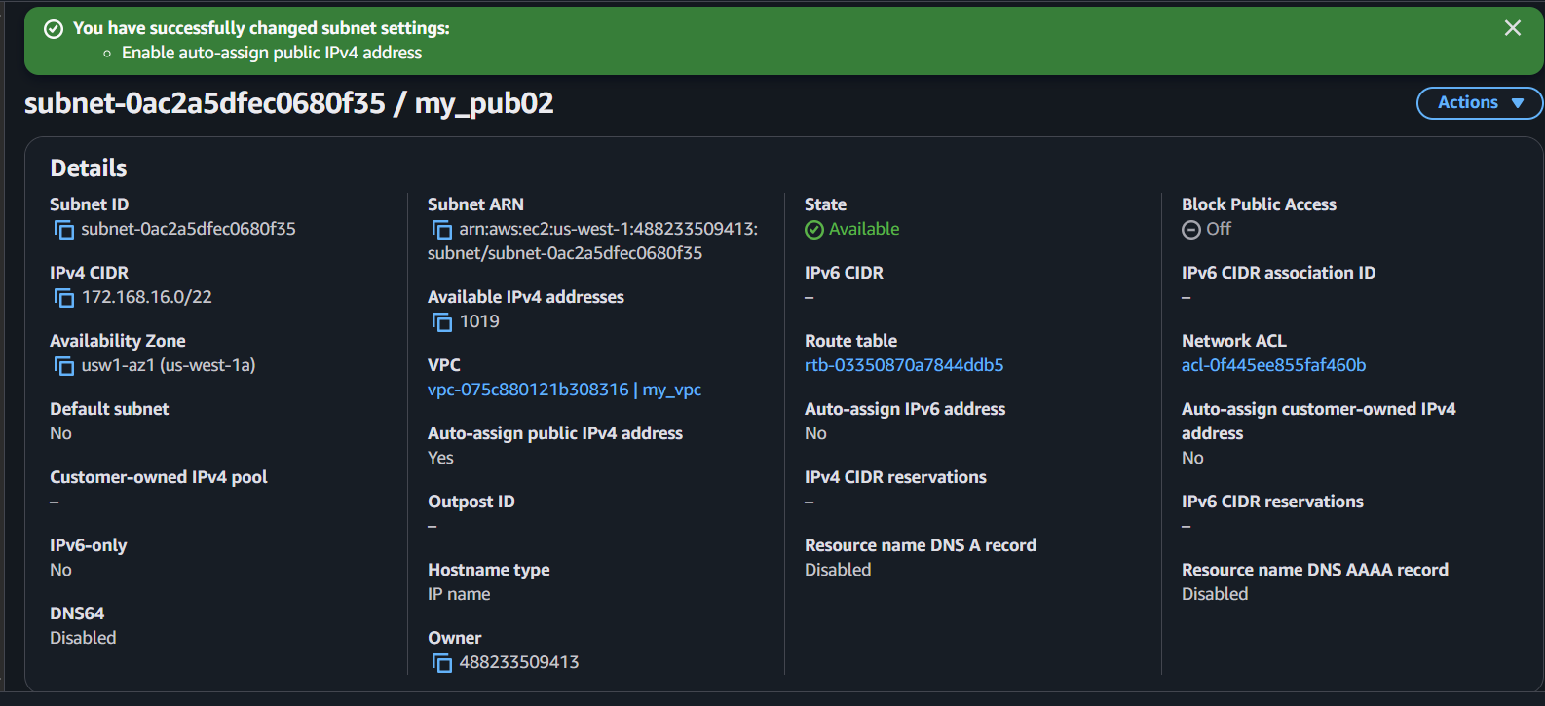

- Add 2 private subnets in private route table.
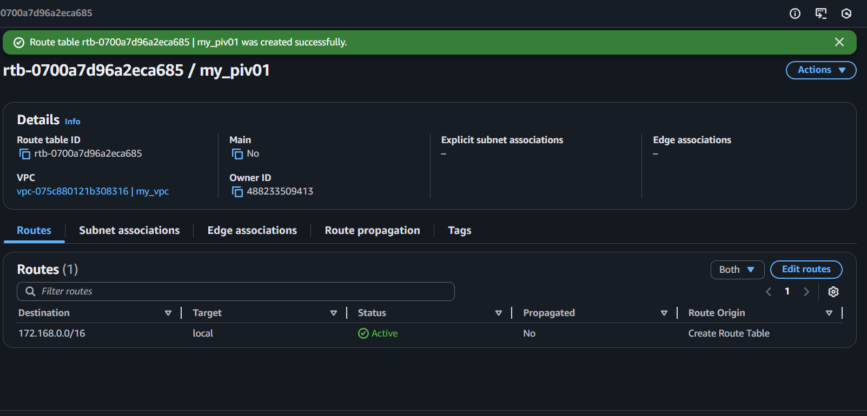

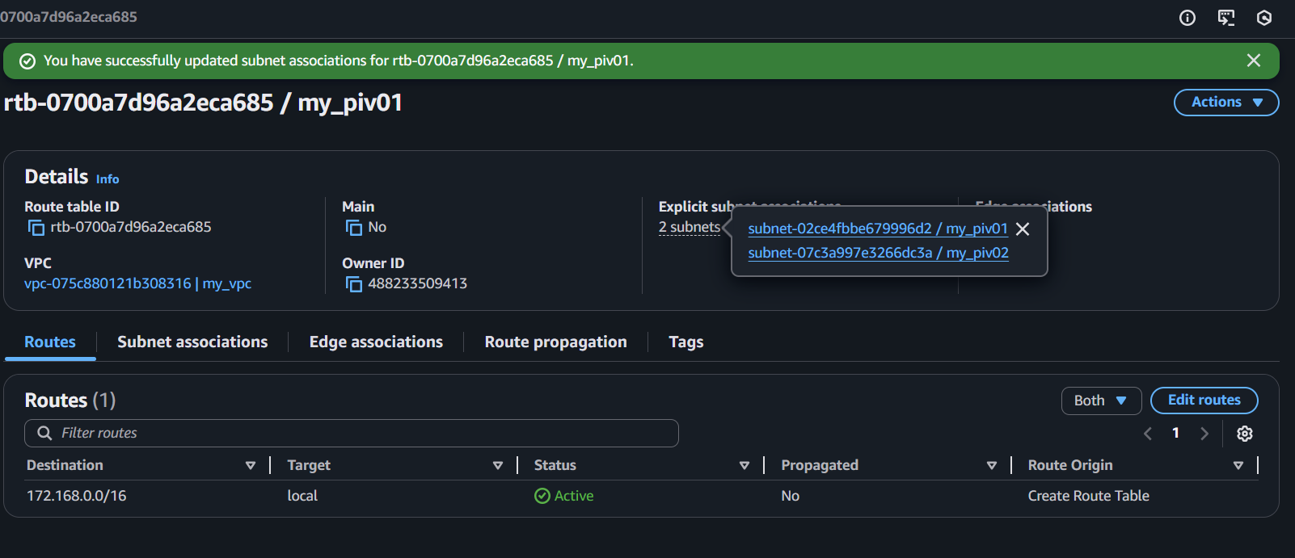

- Add 2 public subnets in public route table.

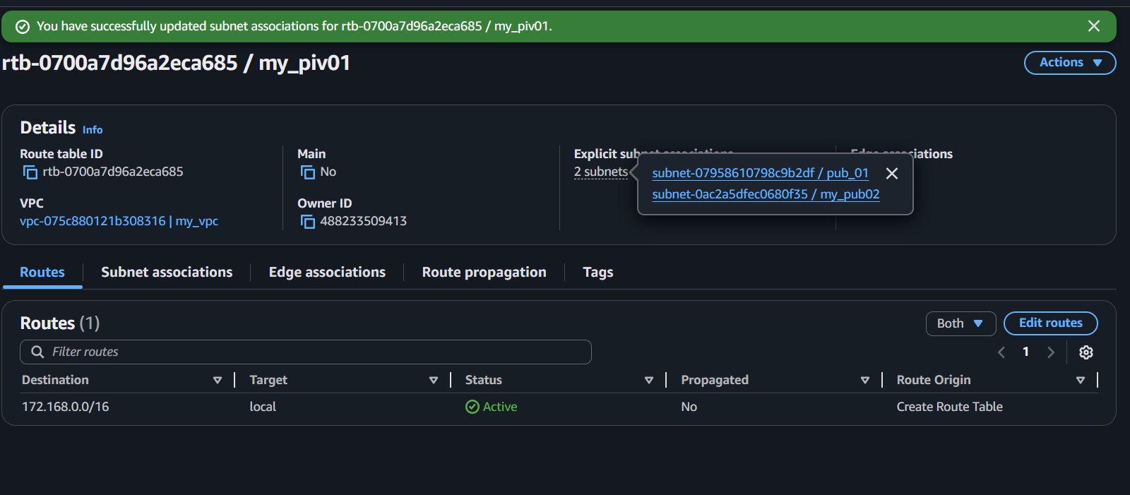

- Public route table will have the routes to internet and local.
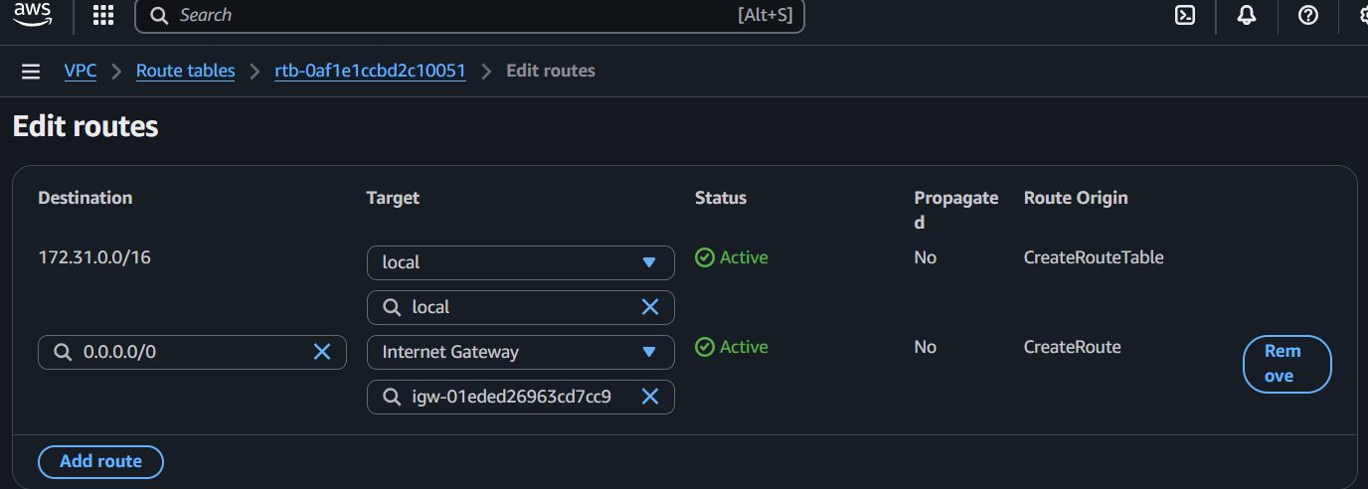

- Create EC2 in public subnet with t2.micro and install PHP.

Steps:
Yum install update -y
Yum install httpd -y
Yum install php -y
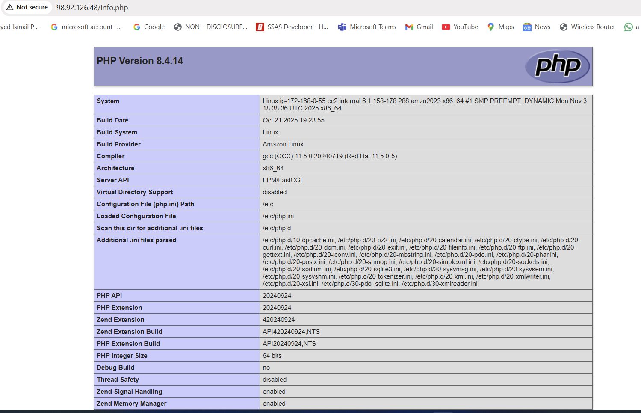
- Configure NAT gateway in public subnet and connect to private instance.
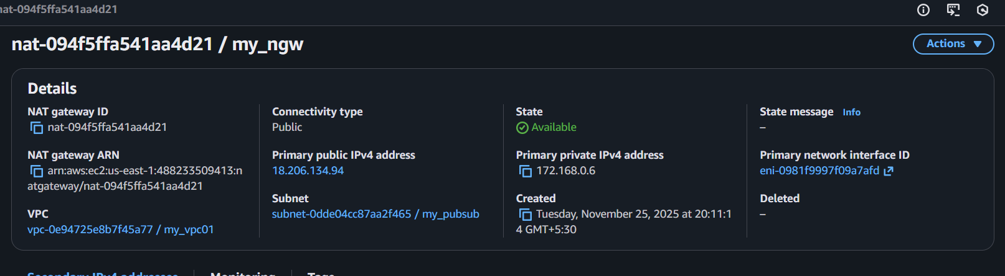
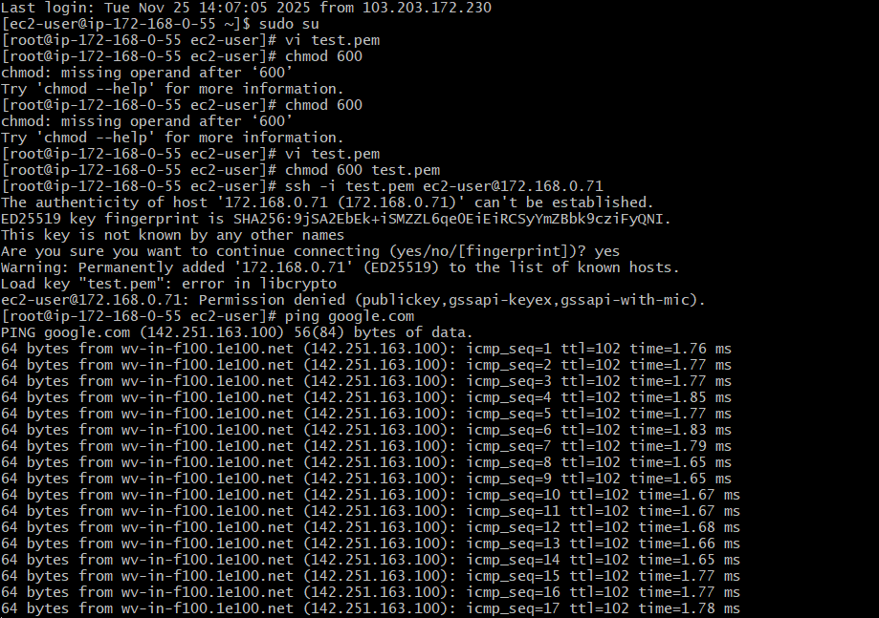

- Install Apache Tomcat in private EC2 and deploy a sample app.
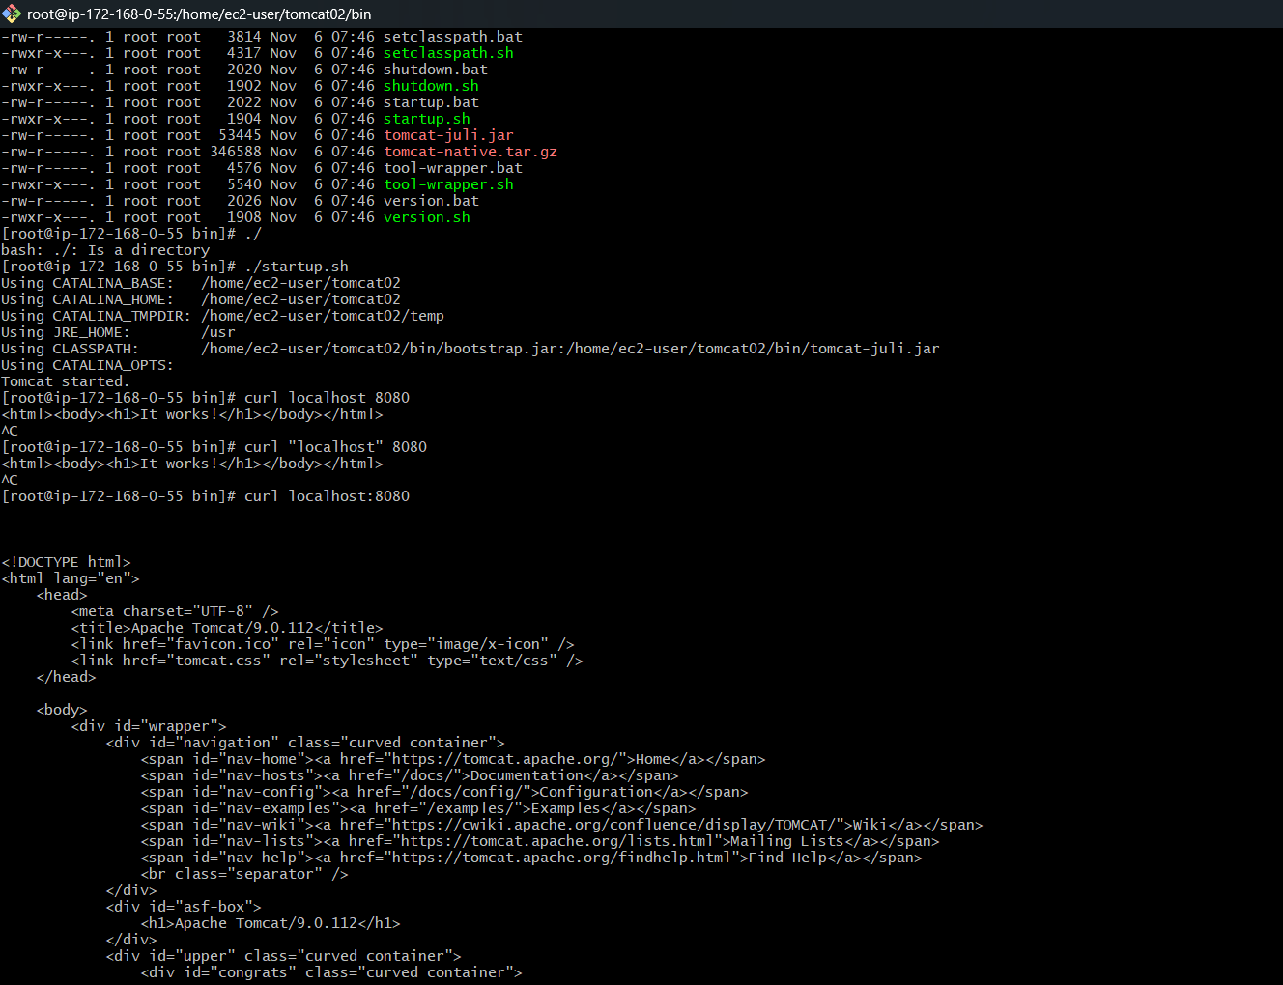

- Configure VPC flow logs and store the logs in S3 and CloudWatch.
Steps:First We have to create a s3 bucket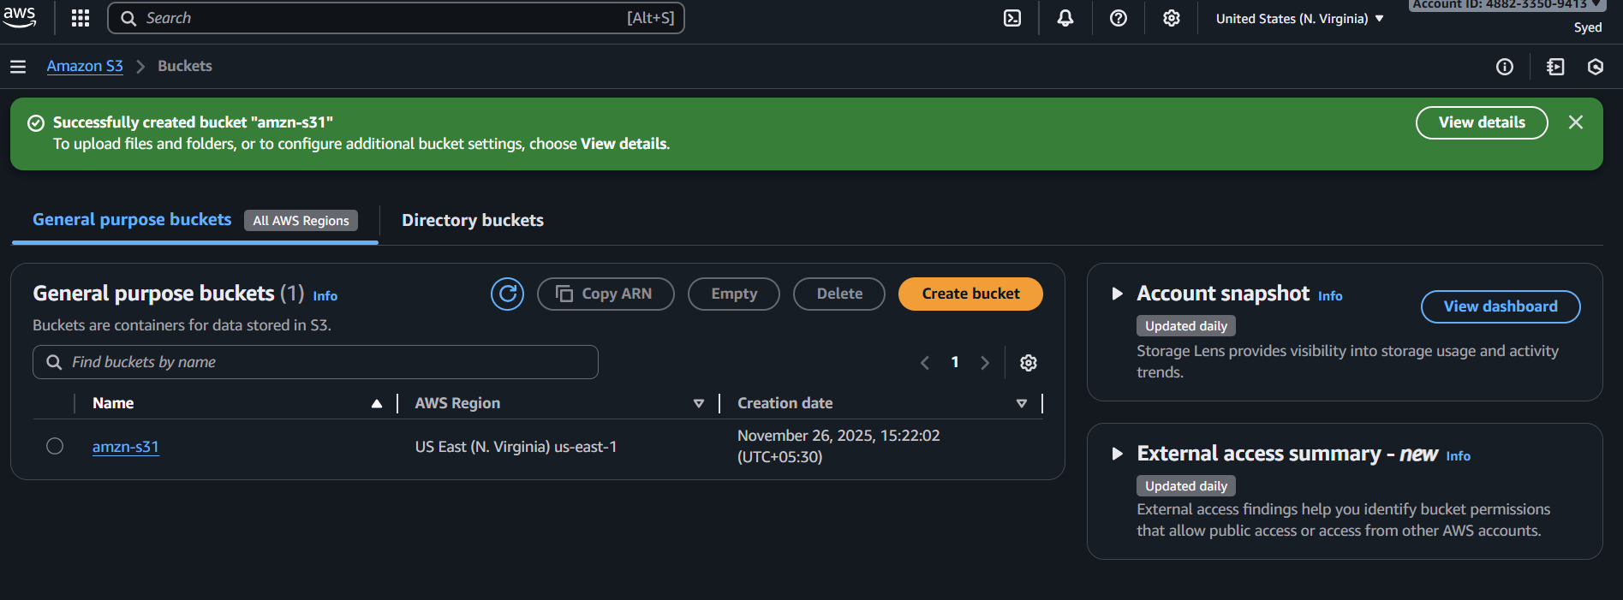
Created successfully flow log in S3 bucket
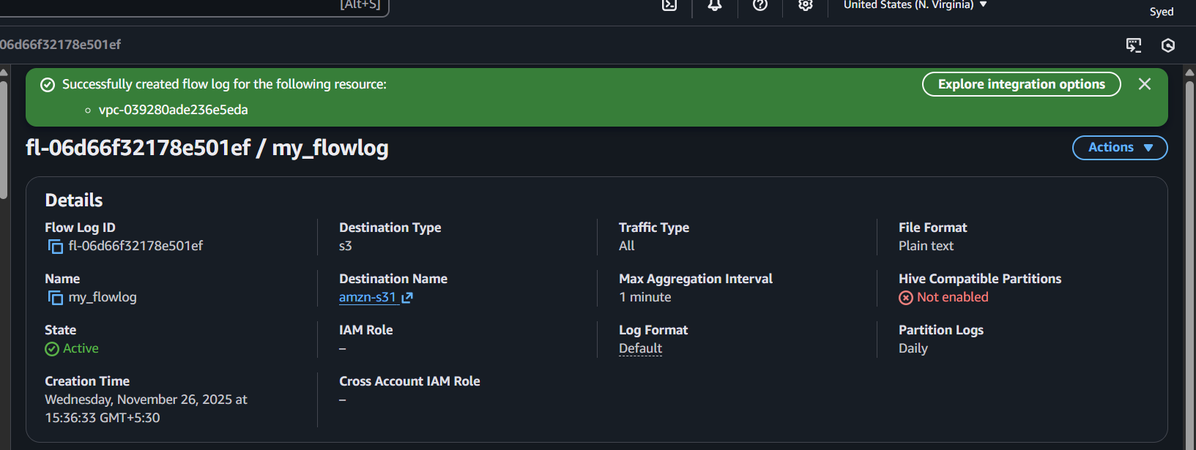

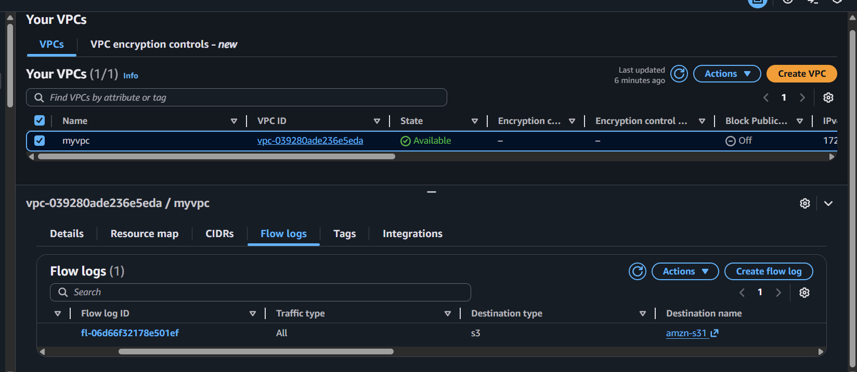

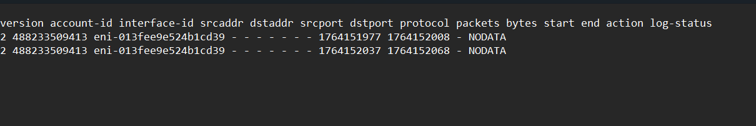

Create a cloud watch
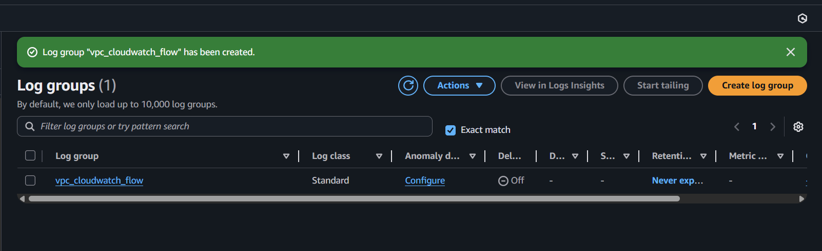

Create one I am
Go to rules and create rules
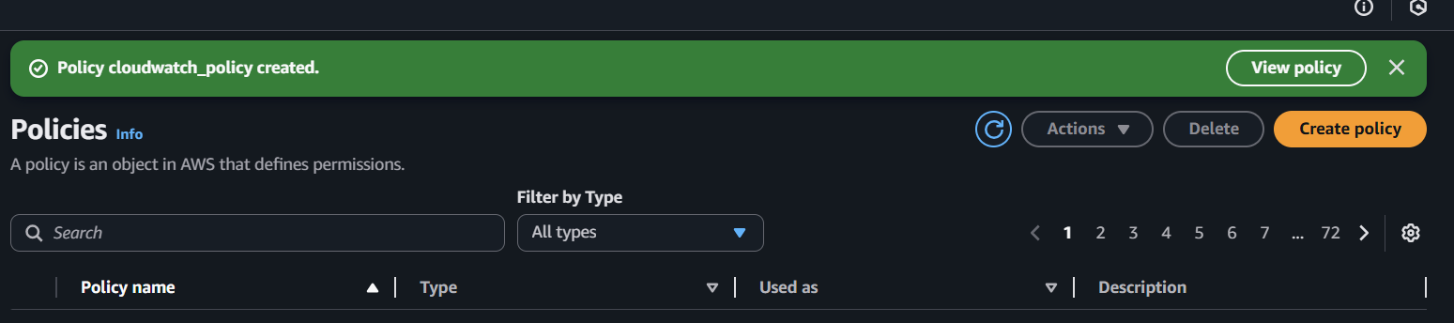

Create a policy and role
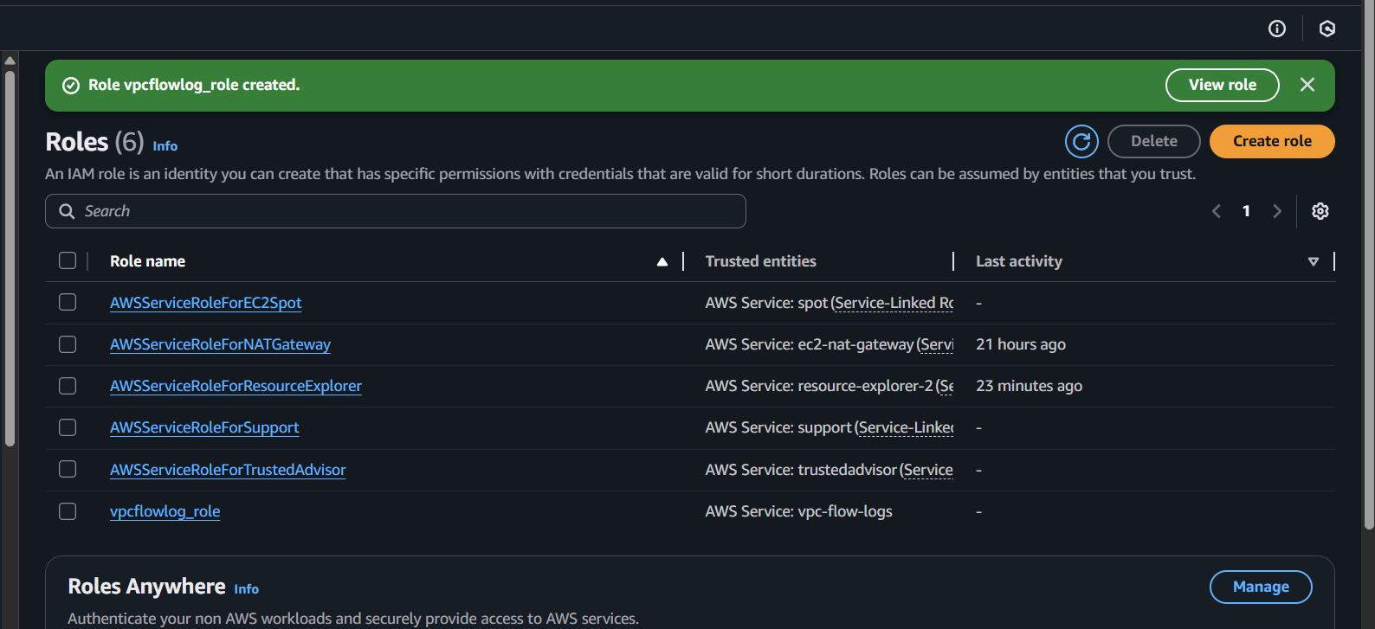

Created flowlog
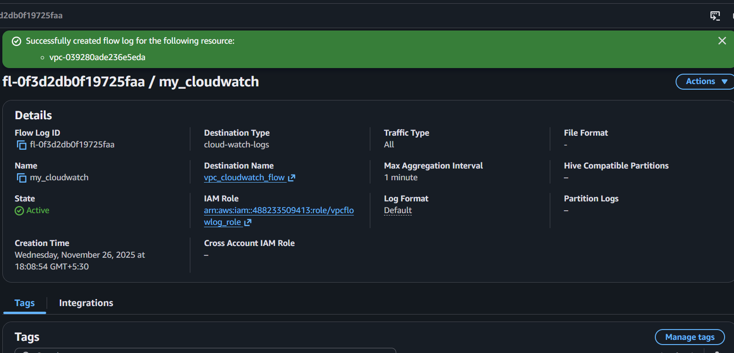

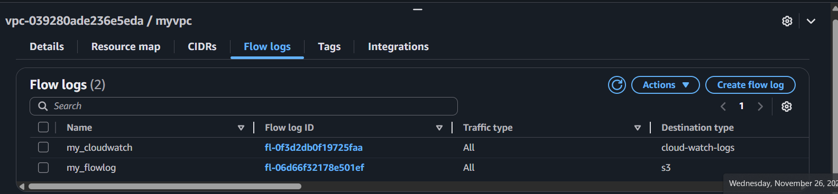

See the log

